Characteristics

Characteristics

[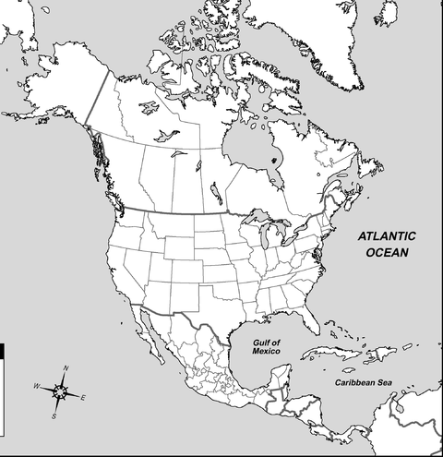](http://www.zonu.com/fullsize-en/2009-11-08-10949/North-America-Political-Outline-Map.html)

Characteristics

Characteristics